CW Sender Part IV: Wrapping It All Up with A PC Keyboard
Ben Kuo, KK6FUT kk6fut@verizon.net
Pete Juliano, N6QW radioguy90@hotmail.com

In this last article in the CW Sender series, we finally put all of the pieces together for a fully independent, stand alone project which you can use to send CW using a PC keyboard and an LCD display. In our three earlier articles, we provided an introduction to the power of the Arduino microprocessor and environment, with the aim of introducing more hams to the flexibility and power of combining software and microprocessors with homebrew Ham radio projects. It's important to note that the purpose of this series was not to create the most efficient code or the ultimate CW keyer; it was to help hardware savvy hams to learn more about software and how it might be applicable to ham homebrewing.

If you've followed us along this journey, we started out with simply blinking LED ON and OFF to send CW (CW Sender Part I), gradually building up to driving a mechanical keyer using the Arduino (CW Sender Part II), to allowing users to type messages to the serial port on your PC and automatically sending that CW from the keyer (CW Sender Part III). In this process, we've shown you a little bit about writing software; helped you learn about subroutines, functions, and libraries; and also given you a little bit of a taste of how easy it is to add hardware like knobs, dials, and LCD displays to the Arduino.

In CW Sender Part II, we left you with an Arduino which was able to take serial port input from your computer, and use that to drive CW output, echoing that output to an LCD screen. The last step we have for CW Sender is to make this entirely independent of your PC, by adding an easy-to-obtain PS/2 keyboard to the project.

The Hardware

Is identical to the CW Sender in Part 3, with the addition of four additional connections. The pins on the PS/2 keyboard connector are +5 and GND, along with two data pins, which we connect to Arduino PIN3 (Clock) and Arduino PIN X (Data). A diagram of this connection is in Figure 1.

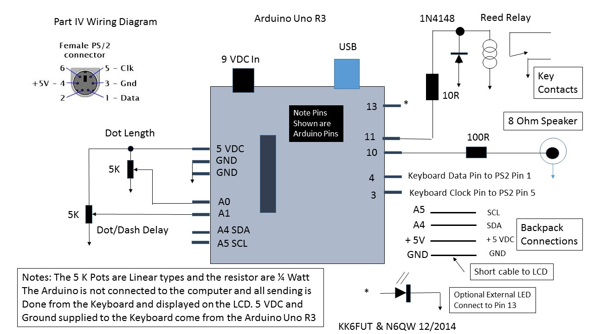
Figure 1. Addition of the PS/2 Keyboard connections to the CW Sender

The Software

Fortunately for us, as is often the case with Arduino, there are pre-existing libraries which help us to implement support for the PS/2 keyboard. We've used the PS2Keyboard library to fully implement all of our keyboard support. The PS2Keyboard library handles all of the software routines needed to intercept keys pressed on the keyboard, and makes them available in a buffer for the software to manage. Note: some versions of the PS2Keyboard library do not support upper and lower case, which is fine for us, as there is no such thing as lower case or upper case in CW!

Setting Up The Software

In order to set up the keyboard libraries, we have to include two lines. The first, shown in Figure 2, is to include the library itself. You'll have to include the library in your code, and also install the proper PS2Keyboard library in the Arduino library location. We've omitted the steps to install a library, which is well documented on the Arduino website. The second part of setting up the software, is to initialize the library, which is done by the PS2Keyboard keyboard declaration. This is an example of one of what is called object-oriented programming, an artifact of the use of C++ type software coding in Arduino. We actually quietly did this in Part II with the Serial class. Understanding how object oriented programming works is way, way beyond the scope of this article, but the important thing to know is that rather than running functions on a variable, an object oriented variable like keyboard has built in functions. This is shown in the keyboard.available() function -- which simply tells if there are characters available in the keyboard buffer when called.

Figure 2. Including the Library

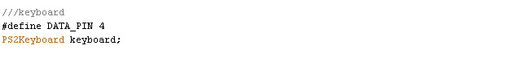
Figure 3. Setting up the keyboard control.

In addition to the declarations of the keyboard, we also have to add another line to our setup routine, which starts the PS2 keyboard monitoring software. You can see that additional line in Figure 4.

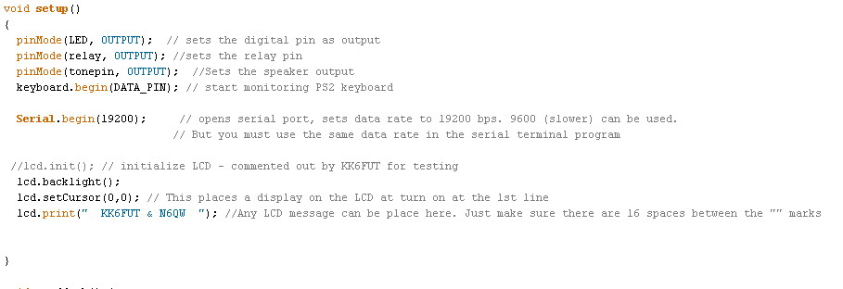
Figure 4. Our new setup() routine.

In our loop() function, which we created before for the earlier version of the CW Sender, we are changing the software to go from monitoring the serial port, to checking the PS/2 keyboard. To do this, we use the PS2Keyboard library to check if any characters are available, and if so, reading that character and acting upon what was received. An example of that follows in Figure 5, where we've shown the snippet of code which checks for input. You'll note that the rest of the software is identical to what we developed in the last article; the only difference here is we are now monitoring the keyboard--not the serial port--for input. In theory, you could write this to accept input from either source, but to simplify the code we're only accepting PS/2 keyboard input in our example.

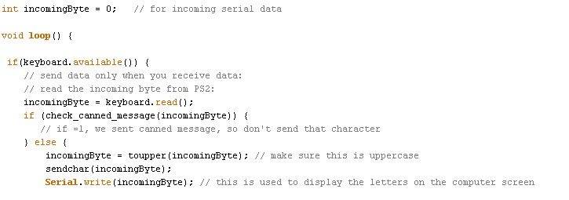
(continued)

Figure 5. Snippet of our new loop routine.

In the new loop, we use the function keyboard.available() to determine if there is keyboard input available; if so, we use keyboard.read() to read that byte. These are analogous to the Serial.available() commands and Serial.read() functions we used for the serial port in Part III.

Conclusion

In this article, we've wrapped up our CW Sender series, showing you how to go from blinking an LED on and off using the Arduino, to creating a fully independent project which you can use to send CW using a PC keyboard and an LCD display. Hopefully, you will have gained some understanding on how you can use Arduino in your ham radio projects, and learned a little bit about software and software building blocks.

Note: The complete Arduino sketch for part IV of the CW sender will be available for download from the following link. About mid-page the sketches for all parts of this series are available for downloading. See http://www.jessystems.com/arduino_build.html.

73’s
Ben, KK6FUT & Pete N6QW

